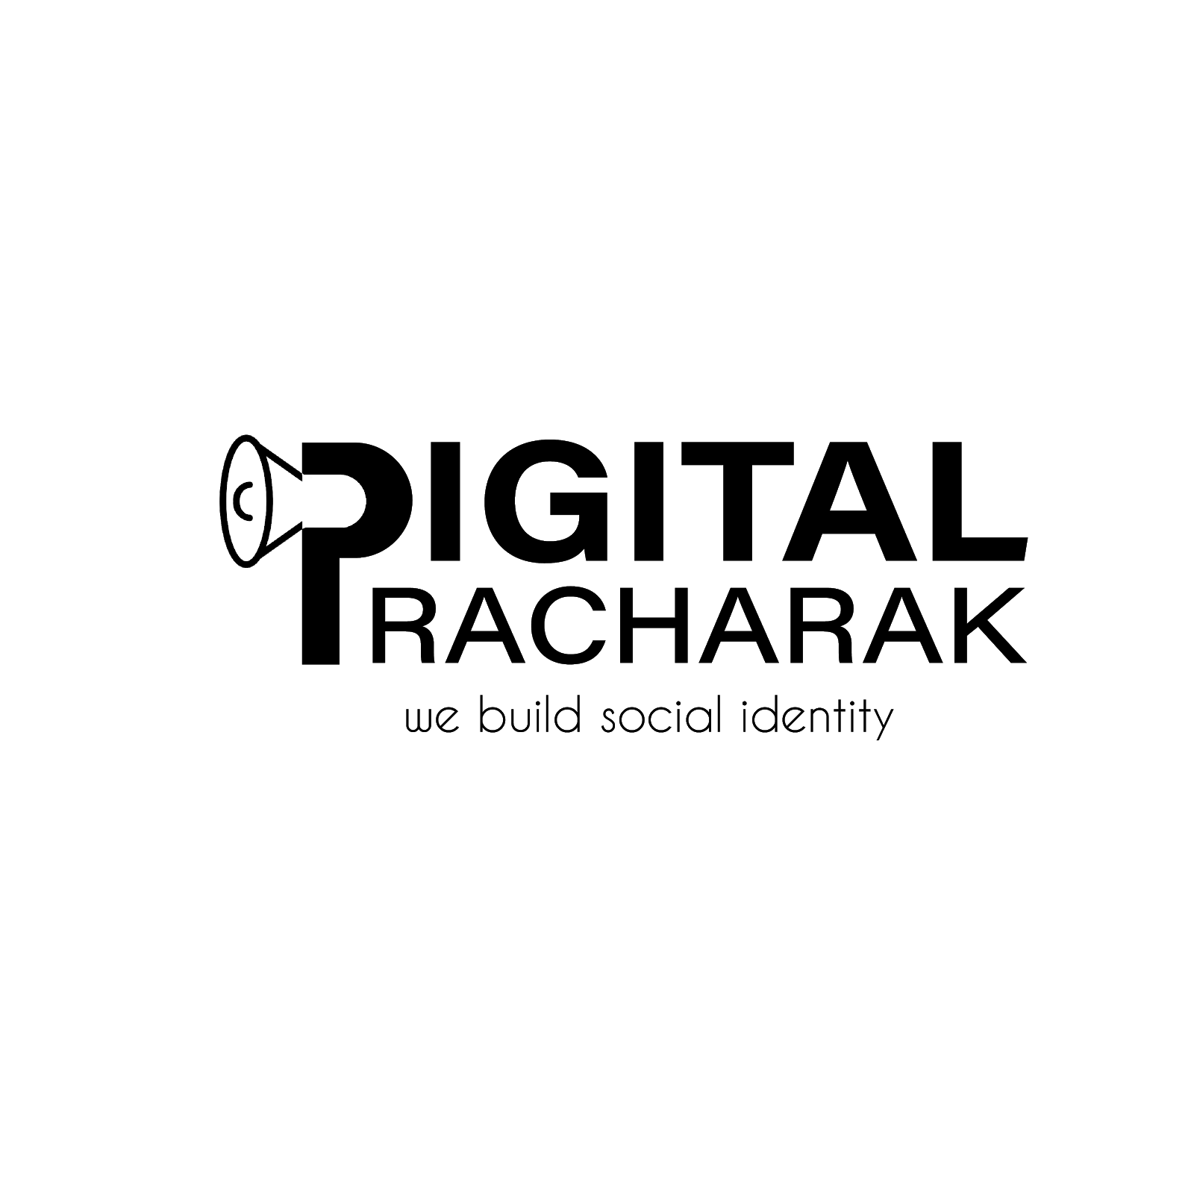
SOCIAL MEDIA MARKETING PROPOSAL

Prepared For- Mr. Samarpan Das Prepared By- Digital Pracharak
Digital Pracharak is a full-service digital marketing agency based in Dehradun and Indore. In today’s digital business world, you need a partner who can help you take advantage of marketing opportunities across a variety of channels in realtime. Digital Pracharak combines a data-driven approach with knowledge gained from years in digital marketing to deliver outstanding results to our clients.

OUR SERVICES
Digital Pracharak is an end-to-end provider of digital marketing services. Whether you’re looking for a turnkey managed strategy, an independent audit, or services specific to a short-term campaign, our experience and approach are sure to prove to be a valuable asset.

SOCIAL MEDIA
Social Media has changed how brands communicate with their audiences forever. Whether your business is a B2B or B2C brand, social media is a powerful way to build brand awareness, build a positive image, and drive lead generation. We specialize in strategic social media campaigns that focus on building and protecting a positive brand image, creating loyalty among fans, and driving new leads for your business.

SERVICES FOR INTERIOR DESIGN PAGE

Instagram-
- 15-20 Posts, reels(as per client’s requirements).

Paid Ads setup and management will be included as well (charges will vary accordingly).
- Promotional Content per month.
- Festival Posts- Cover Picture, Profile Logo

Multiple Group Posting will be provided for better engagement.
- Proper strategy planning in every quarter for better results.
- Instagram Page Insight Report / Month.

Facebook-
- 15-20 Posts, reels(as per client’s requirements).

Paid Ads setup and management will be included as well (charges will vary accordingly).
- Promotional Content

Multiple Group Posting will be provided for better engagement.
- Proper strategy planning in every quarter for better results.
- Festival Posts- Cover Picture, Profile Logo
- Facebook Page Insight Report / Month.

YOUTUBE-
- 4-6 videos(as per your product promotion).
- Promotional Content
- Proper strategy planning in every quarter for better results.

SERVICES FOR ELECTRIC VEHICLE PAGE

Instagram-
- 20-25 Posts, reels(as per client’s requirements).

Paid Ads setup and management will be included as well (charges will vary accordingly).
- Promotional Content per month.
- Festival Posts- Cover Picture, Profile Logo

Multiple Group Posting will be provided for better engagement.
- Proper strategy planning in every quarter for better results.
- Instagram Page Insight Report / Month.

Facebook-
- 20-25 Social Media Posts, reels(as per client’s requirements).

Paid Ads setup and management will be included as well (charges will vary accordingly).
- Promotional Content

Multiple Group Posting will be provided for better engagement.
- Proper strategy planning in every quarter for better results.

Festival Posts- Cover Picture, Profile Logo
- Facebook Page Insight Report / Month.

PRICING
The purpose of this price quotation is to give you clarity over the prices of our services. Kindly check the quotation thoroughly-

INTERIOR DESIGN PAGE- Our price quotation for social media which includes Instagram, facebook and Youtube (according to your requirements) will be Rs.8000/month.

ELECTRIC VEHICLE PAGE- Our price quotation for social media which includes Instagram and Facebook (according to your requirements) will be Rs.7000/month.

*NOTE*
- We always charge 20% before the commencement of the project.
- We separately charge for the paid ads.

For Further Details you can contact undersigned numbers mentioned below:

DIGITAL PRACHARAK 9997240235, 7999817080
digitalpracharak09@gmail.com

